Hands-on Lab : String Patterns, Sorting and Grouping

**Estimated time needed:** 35 minutes

In this lab, you will go through some SQL practice problems that will provide hands-on experience with string patterns, sorting result sets and grouping result sets.

Software Used in this Lab

In this lab, you will use an [IBM Db2 Database](https://www.ibm.com/products/db2-database?utm_medium=Exinfluencer&utm_source=Exinfluencer&utm_content=000026UJ&utm_term=10006555&utm_id=NA-SkillsNetwork-Channel-SkillsNetworkCoursesIBMDeveloperSkillsNetworkDB0201ENSkillsNetwork20127838-2021-01-01). Db2 is a Relational Database Management System (RDBMS) from IBM, designed to store, analyze and retrieve data efficiently.

To complete this lab you will utilize a Db2 database service on IBM Cloud. If you did not already complete this lab task earlier in this module, you will not yet have access to Db2 on IBM Cloud, and you will need to follow the lab below first:

* [Hands-on Lab : Sign up for IBM Cloud, Create Db2 service instance and Get started with the Db2 console](https://cf-courses-data.s3.us.cloud-object-storage.appdomain.cloud/IBMDeveloperSkillsNetwork-DB0201EN-SkillsNetwork/labs/Labs_Coursera_V5/labs/Lab%20-%20Sign%20up%20for%20IBM%20Cloud%20-%20Create%20Db2%20service%20instance%20-%20Get%20started%20with%20the%20Db2%20console/instructional-labs.md.html)

Database Used in this Lab

The database used in this lab is an internal database. You will be working on a sample HR database. This HR database schema consists of 5 tables called **EMPLOYEES**, **JOB_HISTORY**, **JOBS**, **DEPARTMENTS** and **LOCATIONS**. Each table has a few rows of sample data. The following diagram shows the tables for the HR database:

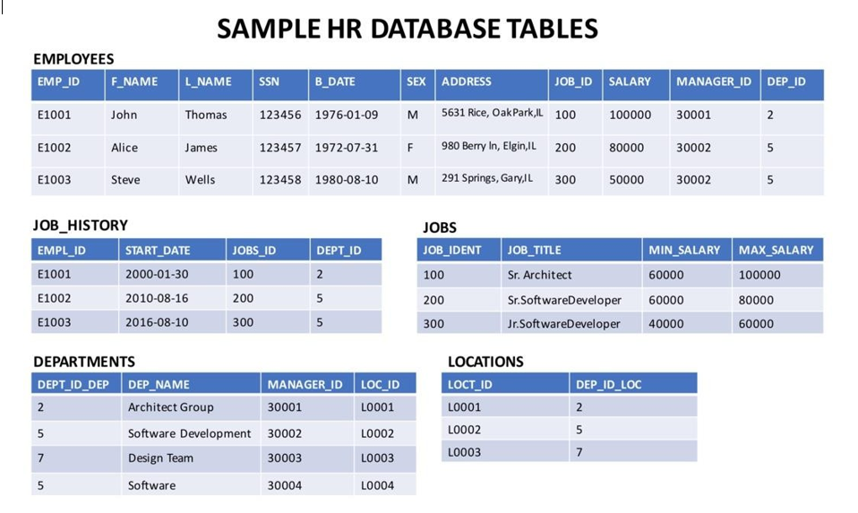

**NOTE:** This lab requires you to have all 5 of these tables of the HR database populated with sample data on Db2. If you didn't complete the earlier lab in this module, you won't have the tables above populated with sample data on Db2, so you will need to go through the lab below first:

* [Hands-on Lab : Create tables using SQL scripts and Load data into tables](https://cf-courses-data.s3.us.cloud-object-storage.appdomain.cloud/IBMDeveloperSkillsNetwork-DB0201EN-SkillsNetwork/labs/Labs_Coursera_V5/labs/Lab%20-%20Create%20tables%20using%20SQL%20scripts%20and%20Load%20data%20into%20tables/instructional-labs.md.html)

Objectives

After completing this lab, you will be able to:

* Simplify a SELECT statement by using string patterns, ranges, or sets of values
* Sort the result set in either ascending or descending order and identify which column to use for the sorting order
* Eliminate duplicates from a result set and further restrict a result set

Instructions

When you approach the exercises in this lab, follow the instructions to run the queries on Db2:

* Go to the [Resource List](https://cloud.ibm.com/resources?utm_medium=Exinfluencer&utm_source=Exinfluencer&utm_content=000026UJ&utm_term=10006555&utm_id=NA-SkillsNetwork-Channel-SkillsNetworkCoursesIBMDeveloperSkillsNetworkDB0201ENSkillsNetwork20127838-2021-01-01) of IBM Cloud by logging in where you can find the Db2 service instance that you created in a previous lab under **Services** section. Click on the **Db2-xx service**. Next, open the Db2 Console by clicking on **Open Console** button. Click on the 3-bar menu icon in the top left corner and go to the **Run SQL** page. The Run SQL tool enables you to run SQL statements.
  + If needed, follow [Hands-on Lab : Sign up for IBM Cloud, Create Db2 service instance and Get started with the Db2 console](https://cf-courses-data.s3.us.cloud-object-storage.appdomain.cloud/IBMDeveloperSkillsNetwork-DB0201EN-SkillsNetwork/labs/Labs_Coursera_V5/labs/Lab%20-%20Sign%20up%20for%20IBM%20Cloud%20-%20Create%20Db2%20service%20instance%20-%20Get%20started%20with%20the%20Db2%20console/instructional-labs.md.html)

Exercise 1: String Patterns

In this exercise, you will go through some SQL problems on String Patterns.

1. Problem:

*Retrieve all employees whose address is in Elgin,IL.*

HintSolution

**SELECT** F_NAME , L_NAME

**FROM** EMPLOYEES

**WHERE** ADDRESS **LIKE** '%Elgin,IL%';

Output

1. Problem:

*Retrieve all employees who were born during the 1970's.*

HintSolution

**SELECT** F_NAME , L_NAME

**FROM** EMPLOYEES

**WHERE** B_DATE **LIKE** '197%';

Output

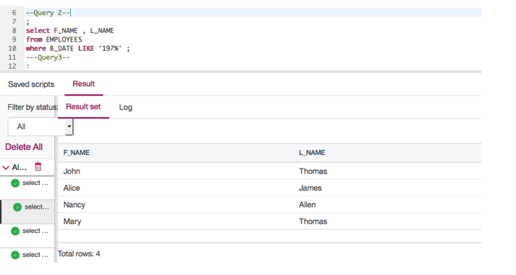

1. Problem:

*Retrieve all employees in department 5 whose salary is between 60000 and 70000.*

HintSolution

**SELECT** *

**FROM** EMPLOYEES

**WHERE** (SALARY **BETWEEN** 60000 **AND** 70000) **AND** DEP_ID = 5;

Output

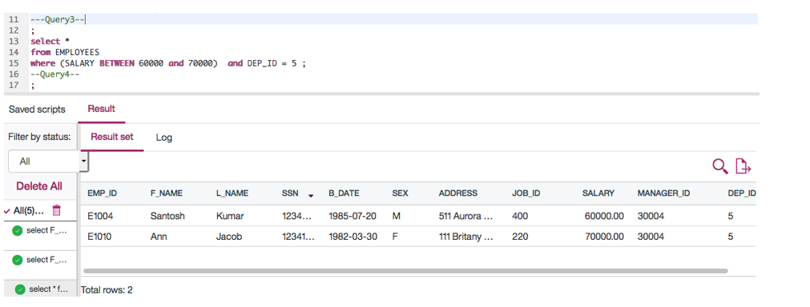

Exercise 2: Sorting

In this exercise, you will go through some SQL problems on Sorting.

1. Problem:

*Retrieve a list of employees ordered by department ID.*

HintSolution

**SELECT** F_NAME, L_NAME, DEP_ID

**FROM** EMPLOYEES

**ORDER** **BY** DEP_ID;

Output

1. Problem:

*Retrieve a list of employees ordered in descending order by department ID and within each department ordered alphabetically in descending order by last name.*

HintSolution

**SELECT** F_NAME, L_NAME, DEP_ID

**FROM** EMPLOYEES

**ORDER** **BY** DEP_ID **DESC**, L_NAME **DESC**;

Output

1. (Optional) Problem:

*In SQL problem 2 (Exercise 2 Problem 2), use department name instead of department ID. Retrieve a list of employees ordered by department name, and within each department ordered alphabetically in descending order by last name.*

HintSolutionOutput

Exercise 3: Grouping

In this exercise, you will go through some SQL problems on Grouping.

**NOTE:** The SQL problems in this exercise involve usage of SQL Aggregate functions AVG and COUNT. COUNT has been covered earlier. AVG is a function that can be used to calculate the Average or Mean of all values of a specified column in the result set. For example, to retrieve the average salary for all employees in the EMPLOYEES table, issue the query: SELECT AVG(SALARY) FROM EMPLOYEES;. You will learn more about AVG and other aggregate functions later in the lecture **Built-in Database Functions**.

1. Problem:

*For each department ID retrieve the number of employees in the department.*

HintSolution

**SELECT** DEP_ID, COUNT(*)

**FROM** EMPLOYEES

**GROUP** **BY** DEP_ID;

Output

1. Problem:

*For each department retrieve the number of employees in the department, and the average employee salary in the department..*

HintSolution

**SELECT** DEP_ID, COUNT(*), AVG(SALARY)

**FROM** EMPLOYEES

**GROUP** **BY** DEP_ID;

Output

1. Problem:

*Label the computed columns in the result set of SQL problem 2 (Exercise 3 Problem 2) as NUM_EMPLOYEES and AVG_SALARY.*

HintSolution

**SELECT** DEP_ID, COUNT(*) **AS** "NUM_EMPLOYEES", AVG(SALARY) **AS** "AVG_SALARY"

**FROM** EMPLOYEES

**GROUP** **BY** DEP_ID;

Output

1. Problem:

*In SQL problem 3 (Exercise 3 Problem 3), order the result set by Average Salary..*

HintSolution

**SELECT** DEP_ID, COUNT(*) **AS** "NUM_EMPLOYEES", AVG(SALARY) **AS** "AVG_SALARY"

**FROM** EMPLOYEES

**GROUP** **BY** DEP_ID

**ORDER** **BY** AVG_SALARY;

Output

1. Problem:

*In SQL problem 4 (Exercise 3 Problem 4), limit the result to departments with fewer than 4 employees.*

HintSolution

**SELECT** DEP_ID, COUNT(*) **AS** "NUM_EMPLOYEES", AVG(SALARY) **AS** "AVG_SALARY"

**FROM** EMPLOYEES

**GROUP** **BY** DEP_ID

**HAVING** count(*) < 4

**ORDER** **BY** AVG_SALARY;

Output

Solution Script

If you would like to run all the solution queries of the SQL problems of this lab with a script, download the script below. Upload the script to the Db2 console and run. Follow [Hands-on Lab : Create tables using SQL scripts and Load data into tables](https://cf-courses-data.s3.us.cloud-object-storage.appdomain.cloud/IBMDeveloperSkillsNetwork-DB0201EN-SkillsNetwork/labs/Labs_Coursera_V5/labs/Lab%20-%20Create%20tables%20using%20SQL%20scripts%20and%20Load%20data%20into%20tables/instructional-labs.md.html) on how to upload a script to Db2 console and run it.

* [StringPattern-Sorting-Grouping_Solution_Script.sql](https://cf-courses-data.s3.us.cloud-object-storage.appdomain.cloud/IBMDeveloperSkillsNetwork-DB0201EN-SkillsNetwork/labs/Labs_Coursera_V5/labs/Lab%20-%20String%20Patterns%20-%20Sorting%20-%20Grouping/StringPattern-Sorting-Grouping_Solution_Script.sql)

Congratulations! You have completed this lab, and you are ready for the next topic.